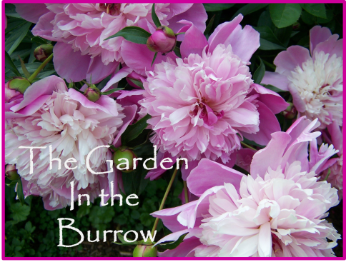
The Garden in the Burrow is a one acre plot lovingly planted and maintained by gardener Cheryl Monroe. The house here was built in the end of 1998, so the oldest of the gardens is a mere 15 years old, and the newest just entering its second season. The land was a former pit of glacially deposited sand, so all the soil, trees, plants, and even ALL the rocks came in via the back of my trusty mini -van and the occasional delivery truck.
The garden spans the entire growing season with some sections peaking in June and July and also sections that are especially planted to peak in late August and September and then follow with lots of winter interest plants. About 100 clematis plants grace the gardens, of which about 30 will be in bloom in late June. Also in bloom should be the many salvias, roses, and spireas that are featured , as well as honeysuckles, penstemons, daylilys, catmint, Shasta daisies, calycanthus, coreopsis, globe thistle, gallardias, trandescantia,campanulas, verbena, dogwood , weigelia and snowberry shrubs, astillbe, bee balms,veronica,geraniums, centaurea, guara, oriental lilies, and of course the containers and annuals. Many different butterfly species and lots of humming birds are daily visitors.
Here in The Burrow there are no separate vegetable or herb gardens, instead you will find the peas, beans, tomatoes, and cukes, grown amid the flowers and the dill, comfrey, feverfew, lavender, thyme, parsley , sage, rosemary, fennel, and angelica, scattered about the grounds. There is also a strawberry bed, 3 apple trees, one pear tree, raspberries and blackberries.
This is a full sun garden, wear your sunhat and pack your sun screen. There are a few respites of shade and of course there will be iced tea, lemonade and cookies on the deck near the gazebo, pergola and in the cabana by the pool area.

